Geometry: Unit 8, Lesson 1

- What is an example of a characteristic of a rhombus?

A figure with four straight sides all the same length

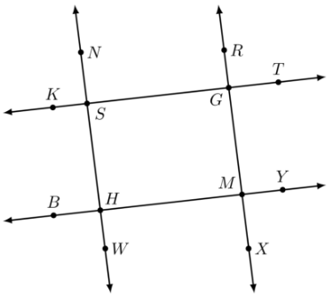

- Lines $NW$, $RX$, $TK$, and $YB$ are shown where $\overset{⃡}{NW}∥\overset{⃡}{RX}$ and $\overset{⃡}{TK}∥\overset{⃡}{YB}$. Given this information, is the statement $∠SHM≅∠MGS$ true?

Yes

- What is true about opposite sides and angles of parallelograms?

Opposite angles are congruent, opposite sides are parallel and congruent

